Mission Flow

A mission can be described as having two components:

- Sunday Drive. This component describes what the user does to launch a “gameplay mission start” event. The things you can be asked to in this context are:
  - Go to a person on-foot (triggers a conversation)
  - Get into a specific car (triggers a driver/passenger conversation)
  - Drive a specific car to a location (trigger volume)
  - There can be more than one of these objectives in a Sunday Drive sequence
  - If there is more than one objective, then only the final one will launch the “gameplay mission start” event
- Gameplay. The Gameplay component has two things that Sunday Drive doesn’t:
  - A more comprehensive list of objectives that the user might have to complete (i.e., the Sunday Drive list is a subset of this one)
  - Failure conditions – gameplay ends in failure if various conditions are met (e.g., a mission timer runs to zero)

The flow of missions throughout a level is illustrated in Figure 1 – Mission Flow.

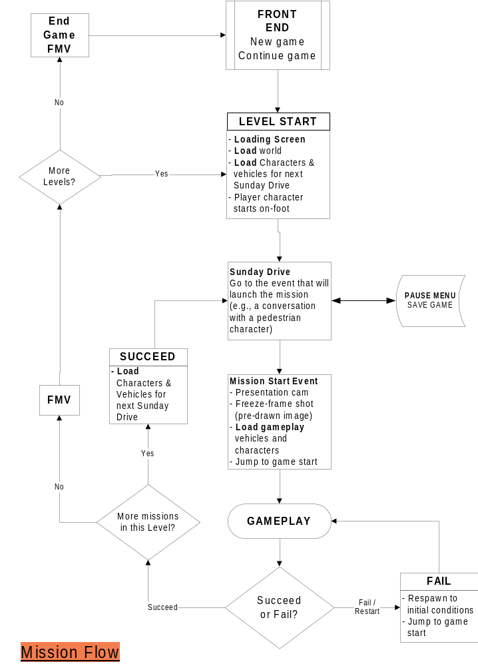

Figure 1

Objectives

Definition: An objective is something the user is asked to do. It is also defined as a discreet game state. In other words, an objective is independent of anything that happened before or will happen after it. (Objectives will appear connected to the user – but an objective definition contains all the information to set up a specified situation).

There are six basic objectives given to the user:
- GO TO [location | vehicle | pedestrian]
- DELIVER N items TO destination
- COLLECT N items
- DRIVE [vehicle] TO destination
  - Drive means you must be in the vehicle when you get to the destination – getting there on foot doesn’t count (GO TO is more general – you can walk or drive)
- FOLLOW vehicle TO destination
- DESTROY N [items | vehicles]

Sunday Drive Objectives

Sunday drive is a series of simple, linear “GO TO”, “DRIVE”, or “PICKUP” objectives. When the final objective is complete the mission-start presentation begins (see presentation document). These three directives can set up the four things that can launch a mission:

- Go to a person on-foot (triggers a conversation)
- Get into a specific car (triggers a driver/passenger conversation)
- Drive a specific car (or your choice of car) to a location (trigger volume)

Example One – Get in to a Car

Description: Get into Homer’s Car
Script:
GO TO VEHICLE Homers_Car //”Homers_Car” is a Maya
// locator
MISSION_START_PRESENTATION Homer // Focus the camera on
// Homer for the
// start-presentation

Example Two – Talk to Two People

Description: Bart (the walking user character) talk to Apu; then Moe
Script:
GO TO CHARACTER Standing_By_Kwik_E-Mart
GO TO CHARACTER Standing_By_Moes
MISSION_START_PRESENTATION Bart // Focus the camera on
// Bart

Notes:
- “Standing_By_Kwik_E-Mart” is a locator in Maya. The script needs to tell the game who is standing there, and what their dialog is.
- Do Sunday Drive missions also need a character [on foot] start location? That is, for when you load a saved game or select/jump to a mission?

Example Three – Get into a Car and Drive to Start Location

Description: Get into Homer’s car, then drive it to the School
Script:
GO TO VEHICLE Homers_Car
DRIVE Homers_Car TO School__L1M3_Start
MISSION_START_PRESENTATION Bart

Gameplay Objectives

A gameplay mission can use any objective. A big difference is that a gameplay mission has only one objective. If we want to link a DELIVER objective to a DESTROY objective, it would actually be two missions.

- GO TO [location | vehicle | pedestrian]
- DELIVER N items [TO | FROM] destination
  - Two types of delivery mission: SEQUENTIAL_ORDER (no choice of order – user gets the items in pre-determined order) or USER_CHOOSES_ORDER
- COLLECT N items
  - Just collect them, but without any delivery component
- DRIVE [vehicle] TO destination
  - Drive means you must be in the vehicle when you get to the destination – getting there on foot doesn’t count (GO TO is more general – you can walk or drive)
- FOLLOW vehicle TO destination
- DESTROY N [items | vehicles]
  - Two types of destruction mission: SEQUENTIAL_ORDER (no choice of order – user destroys the items in pre-determined order) or USER_CHOOSES_ORDER

There are two other additional components to a gameplay mission – failure conditions, and “other attributes” (game times and so on).

Failure Conditions

Failure conditions define what will result in mission failure. There can be more than one for a mission:
- PLAYER VEHICLE DESTROYED
- PLAYER VEHICLE DAMAGED
- PLAYER STRUCK BY VEHICLE WHILE ON FOOT
- AI_VEHICLE vechicle_name ARRIVES FIRST AT destination (i.e., it’s a race)
- TIMER N EXPIRED – N is the # of seconds initially on a game timer (if this condition is omitted, then there is no game clock displayed on the HUD)
- PLAYER GETS OUT OF VEHICLE???
- FAILURE TRIGGER VOLUME – a mission or level can have a trigger volume that causes the mission to fail; this is used for “out of bounds” areas such as large bodies of water
- Note: The game will have a “safety valve” whereby you can skip a mission after failing it N times (designers will tune the number N). This will be recorded in your mission completion status.

Other Attributes

Other things that a gameplay mission must account for:
- Mission setup data that refers to Maya world builder locators:
  - AI Vehicle identities and start locations
  - Player vehicle/on-foot start location
  - Character/Collectible content and locations, e.g.:
    - Apu is standing by the Kwik-E-Mart and talking to him represents collecting a Squishee
- Mission-specific dialog
  - Conversations
  - Mission-specific navigation dialog (e.g., a training line)
- Presentation triggers
  - Camera work and presentation (e.g., you trigger a switch – the game has to show you what you’ve done)
- AI settings:
  - Specify which AI Vehicles will be triggered by proximity?
  - Specify which AI Vehicles are enabled, based on mission conditions
    - e.g., Vehicles 1 through 20 may all be triggered by proximity, but after you’ve destroyed or pickup up an object then Vehicles 1a through 20a are also enabled
    - When you destroy or pickup another object then vehicle 1b through 20 b are also enabled
  - Specify how others AI vehicles are triggered, e.g.:
    - Vehicle 1 activation triggers vehicles 3 & 4
  - Set aggression, strength, and speed of AI vehicle(s) globally for the mission, or based on mission conditions (collectibles and destructibles), e.g.:
ON_COLLECT_2 AI_AGGRESSION_MEDIUM
ON_COLLECT_3 AI_AGGRESSION_HIGH
ON_COLLECT_2 AI_SPEED_HIGH
- TIMER - are there any things that will add time back onto the timer?
- Bonus criteria and definition. The two criteria are time remaining and your damage level, one of which will be used for each mission, e.g:
GOLD TIME_LEFT 10
SILVER TIME_LEFT 5
or
GOLD VEHICLE_CONDITION 100%
SILVER VEHICLE_CONDITION 50%
- VEHICLE REQUIREMENT???

Gameplay Example Objectives
The following gameplay script examples are taken from our first ten gameplay missions:

- Level 1: FOLLOW Marge TO Kwik-E-Mart
- Level 2: DELIVER 1 item TO destination
- Level 3 GO TO destination (race - failure condition is other vehicle getting there first)
- Level 4: DRIVE vehicle TO destination
- Level 5: DESTROY vehicle (start on-foot)
- Level 6: GO TO destination
- Level 7: DESTROY 4 items
- Level 8: Follow AI to destination
- Level 9: DELIVER 1 item TO destination

Real-time AI Scripting

There are a small number of things that the mission-scripter needs to be able to control in real-time, during gameplay:
- Activating certain AI cars on trigger volumes, or upon the activation of another specific AI car (which is activated by proximity)
- Activating or de-activating an animated bounding volume (i.e., turn on the ferry or a drawbridge, open/close a barrier, etc.)
  - Including dynamic physics-object bvs, such as a scripted vehicle
- Add time to the game-timer?
  - Do we need this? If so, what’s the associated presentation?
- Hide from chase AI?
- Pause/re-enable chase AI? (i.e., they come to a stop until you re-activate them at another script?)

